

**DEPARTMENT OF ARTIFICIAL INTELLIGENCE AND DATA SCIENCE**

**Project Title: Health Care Logistics**

**PROJECT AND TEAM DETAILS**

**Members:**

|  |  |
| --- | --- |
| **TEAM MEMBERS** | **ROLL NO** |
| CH.BHARGAV CHARY | 2110080061 |
| T.ASHISH MANOJ | 2110080064 |
| M.GANESH | 2110080050 |
| P.JYOTHIR KRISHNA | 2110080067 |
| T.ANURAG SRIVASTAV | 2110080013 |

**Abstract:**

The main objective of this project is to create a web application using Java, for a healthcare. Logistics company to maintain a record of its test’s and technicians. A logistics and technicians tracking website that allows a customer to search for all the booking date time and location, Technicians assigned for a booking, also allows customers to check the logistics used for bookings and unique data for the logistics required.

**Modules included :** Manager, Technicians, Customer

Manager Module: This module is for managing the overall operations of the healthcare logistics system. It includes features such as managing customer orders, assigning technicians to orders, tracking order status, generating reports, and managing system settings.

Technicians Module: This module is for technicians who will be dispatched to fulfil customer orders. It includes features such as accepting and completing orders, updating order status, communicating with customers, and viewing order history.

Customer Module: This module is for customers who will be placing orders for healthcare logistics services. It includes features such as creating and managing customer profiles, placing orders, tracking order status, and providing feedback on service quality.

**Objective:**

The objectives aim to create a reliable, efficient, and secure healthcare logistics system that helps healthcare facilities manage their inventory and supply chain more effectively.

1. To design and develop a web-based healthcare logistics system that automates the process of managing the delivery of medical supplies, equipment, and medications to healthcare facilities.
2. To provide a platform for healthcare facilities to easily order and track their inventory of medical supplies and equipment in real-time.
3. To improve the efficiency of healthcare logistics operations by automating the process of inventory management, order processing, and delivery scheduling.
4. To reduce the cost and time associated with healthcare logistics by eliminating the need for manual paperwork, phone calls, and faxes.
5. To provide healthcare facilities with an easy-to-use, intuitive interface that requires minimal training and support.
6. To ensure the security and privacy of patient data by implementing appropriate security measures such as encryption, access control, and audit trails.
7. To enable healthcare facilities to generate reports and analytics on their inventory usage, order history, and delivery performance for better decision making.
8. To enhance the scalability and flexibility of the healthcare logistics system by utilizing modern web technologies such as JSP, Servlets, HTML, CSS, and SQL databases.

**Architecture:**

* The model represents the data and business logic of the application.
* In this system, the model can be implemented using a database management system (DBMS) to store and retrieve data related to inventory management, order processing, and delivery scheduling.
* The LoginDetails.jsp, insert.jsp, registration.jsp, onlineproduct.jsp, and View.jsp pages can interact with the model to retrieve, insert, update, or delete data from the database.
* The view represents the user interface of the application.
* In this system, the view can be implemented using JSP pages, HTML, and CSS to display data and receive user input.
* The index.jsp, login.jsp, registration.jsp, onlineproduct.jsp, searched.jsp, and View.jsp pages can be considered as views in the architecture.
* The controller acts as an intermediary between the model and the view, handling user input and updating the model and view accordingly.
* In this system, the controller can be implemented using Servlets to process HTTP requests and responses.
* The Validate.jsp and searched.jsp pages can be considered as controllers in the architecture.

**Codes:**

LoginDetails.java:

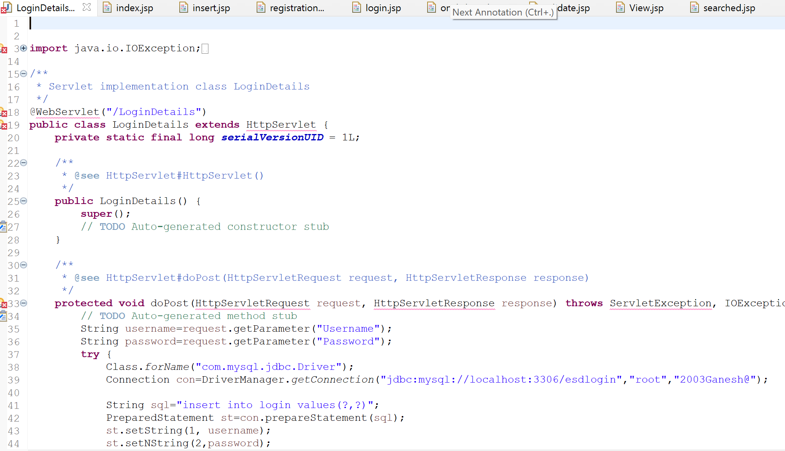

index.jsp:

insert.jsp:

registration.jsp:

login.jsp:

onlineproduct.jsp:

Validate.jsp:

searched.jsp:

View.jsp:

**Description:**

* LoginDetails.jsp: This page can be used to display login details, such as the username and password. It can interact with the model to retrieve the login details from the database.
* index.jsp: This page can be used as the main page of the application, displaying links to different sections of the application. It can also contain a login form to authenticate users.
* insert.jsp: This page can be used to insert data into the database, such as new orders or delivery schedules.
* registration.jsp: This page can be used to register new users, capturing user details such as name, email address, and password. It can interact with the model to insert new user details into the database.
* login.jsp: This page can be used to authenticate users, capturing user credentials and validating them against the database. It can redirect users to the appropriate page based on their role or permissions.
* onlineproduct.jsp: This page can be used to display the list of available products, along with their prices and descriptions. It can interact with the model to retrieve the product data from the database.
* Validate.jsp: This Servlet can be used to handle user authentication, validating user credentials and setting user roles and permissions based on the user's status.
* searched.jsp: This page can be used to display search results for products, orders, or deliveries. It can interact with the model to retrieve the search data from the database.
* View.jsp: This page can be used to display detailed information about a selected product, order, or delivery. It can interact with the model to retrieve the detailed data from the database.

**Output:**

Login Page:

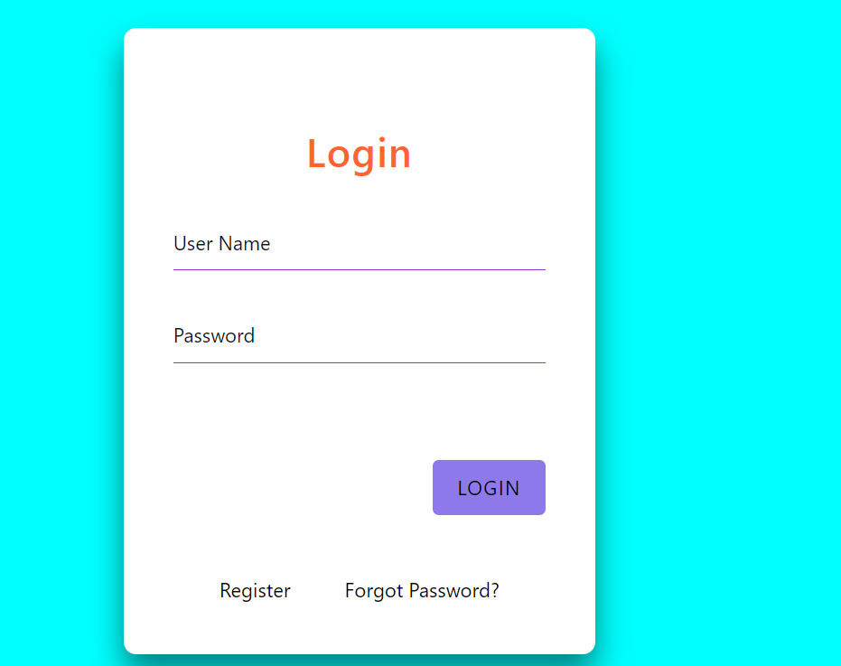

Home Page:

Product Details:

Cart:

**Conclusion:**

The system provides features such as inventory management, order processing, and delivery scheduling to streamline the logistics process and ensure timely delivery of products.

The LoginDetails.jsp, index.jsp, insert.jsp, registration.jsp, login.jsp, onlineproduct.jsp, Validate.jsp, searched.jsp, and View.jsp pages work together to provide a user-friendly interface for users to interact with the system. The system uses a database management system to store and retrieve data related to inventory management, order processing, and delivery scheduling.

The JSP pages and Servlets have been designed to handle different aspects of the system, such as user authentication, data retrieval and manipulation, and search functionality. The pages have been designed using HTML and CSS to ensure a consistent look and feel throughout the application.

Overall, the healthcare logistics system using JSP, Servlet, databases, HTML, and CSS is a powerful tool for healthcare organizations to manage their supply chain efficiently. With its user-friendly interface and comprehensive features, the system can help organizations improve their logistics process and ensure timely delivery of healthcare products.